~Asia-China-Mirror-TLV-Square
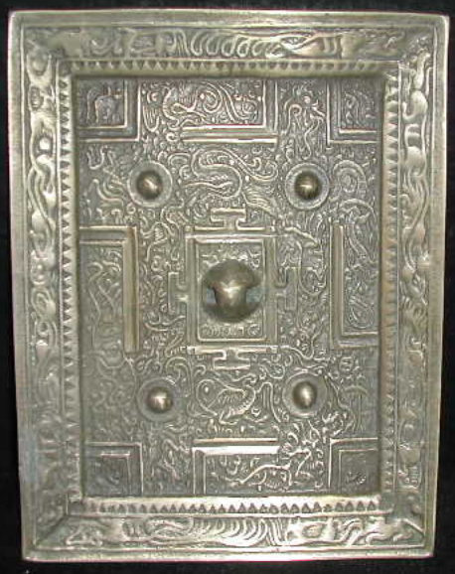
length: 17.00cm
Width: 13.00cm
Thickness:1.00cm
Weight: 0.8 kg
